Romanesque Art
1000-1200 CE
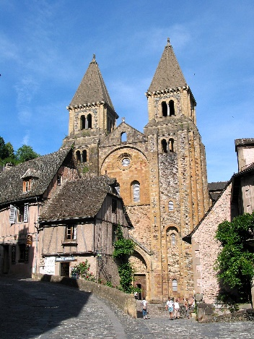

Discuss how the design of the Romanesque church at Sainte-Foy reflects symbolic and practical functions. Discuss how two design elements contributed to the religious experience for medieval Christians.

VOCABULARY
Arcade-

Archivolt-

Baptistery-

Bay-

Campanile-

Cathedral-

Clerestory-

Compound pier-

Embroidery-

Jamb-

Last Judgement-

Mandorla-

Narthex-

Portal-

Radiating chapel-

Reliquary-

Rib Vault-

Tapestry-

Transept-

Transverse arch-

Triforium-

Trumeau-

Tympanum-

Vault-

Voussoir-

