Medieval Periods
Late Antique 200-500CE

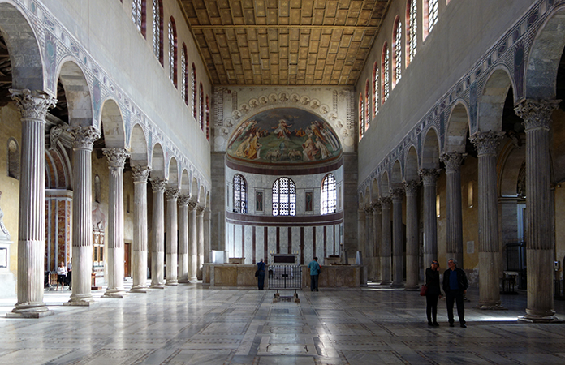

This image is the interior of Santa Sabina in Rome. Describe two elements of the Christian design that were adapted from non-Christian sources. How does the design of this space accommodate Christian ceremonies of the time?

VOCABULARY

Ambulatory-

Apse

Atrium-

Axial Plan-

Basilica-

Caracomb-

Central Plan-

Clerestory-

Coffer-

Cubicula-

Gospels-

Loculi-

Lunette-

Narthex-

Nave-

Orant figure-

Spolia-

Transept-

