Islamic Art
630 CE to Present

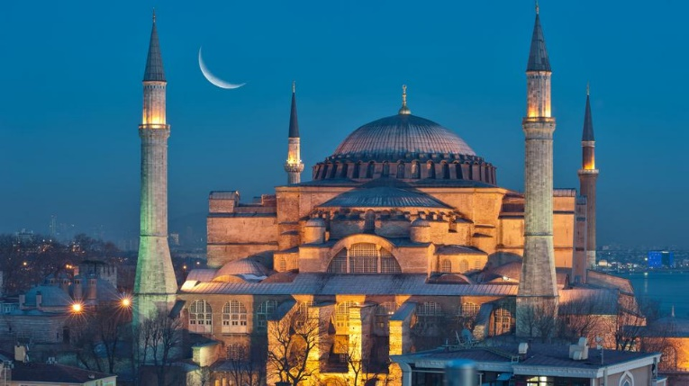

Fully identify the structure. What was the original religious context and how was it adapted for use in a different religious context?

VOCABULARY
Arabesque-

Calligraphy-

Hajj-

Illuminated Manuscript-

Iwan-

Jali-

Kufic-

Mausoleum-

Mecca-

Mihrab-

Minaret-

Minbar-

Mosque-

Muezzin-
Muhammad-

Muqarna-

Pyxis-

Qibla-

Qur’an-

Shahnama (The Book of Kings)

Tessellation-

Voussoirs-

