Early Medieval Art
450-1050
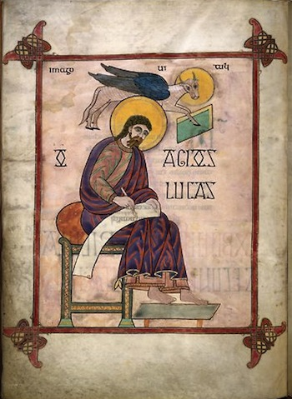
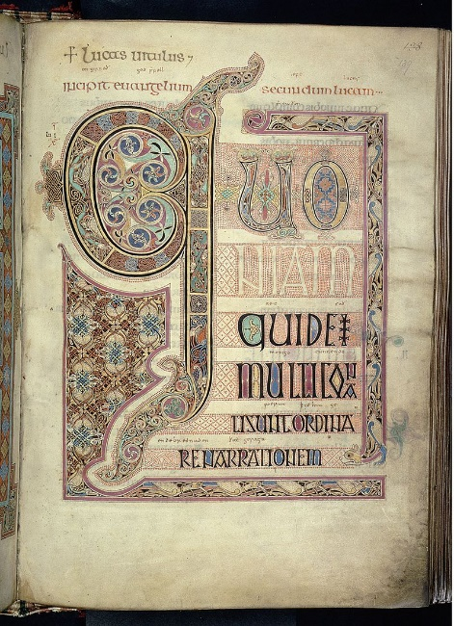

These two pages are from the Lindisfarne Gospels. Identify the work completely and discuss how the pages show influence of both classical and non-classical traditions.

VOCABULARY
Animal style-

Chasing-

Cloissonne-

Codex-

Colophon-

Fibula-

Gospels-

Horror vacui-

Illuminated manuscript-

Parchment-

Scriptorium-

Zoomorphic-

