Byzantine Art
Early Byzantine 500-726
Iconoclastic Controversy 726-843
Middle and Late Byzantine 843-1453
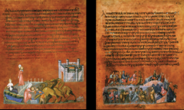

These images are pages from the Vienna Genesis: Rebecca and Eliezar at the Well (left) and Jacob Wrestling the Angel (right)
Fully identify the work. Include specific details about the motifs taken from Classical art and explain how and why these stylistic choices are incorporated into this work.

VOCABULARY
Cathedral-

Chalice-

Codex-

Continuous narrative-

Cornice-

Encaustic-

Eucharist-

Genesis-

Icon-

Iconoclastic Controversy-

Iconostasis-

Illuminated Manuscript-

Martyrium-

Mosaic-

Paten-

Pendentive-

Squinch-

Theotokos-

XP-

